Revision History
Date | Version | Description | Author
04/10/25 | 1.1 | Added document overview and abbreviations (may be updated in the future) | Tuna Özen
05/10/25 | 2.0 | Added Gantt Chart | Tuna Özen
05/10/25 | 2.1 | Updated Gantt Chart (some tasks were missing) | Tuna Özen
07/10/25 | 3.0 | Added and updated Risk assessment, software design, responsibilities table. | Özgür Yılmaz
07/10/25 | 3.1 | Updated responsibilities table, fixed layout design errors | Alp Eren Erdur
07/10/25 | 3.2 | Set up and configured the development environment, installed necessary tools, and ensured all components were properly integrated for team use. | Murad Seyfullayev
14/10/25 | 4.0 | Updated Document Overview, Requirements management and documentation, Project references, Workstation, Risk analysis and planning according to the feedback. | Tuna Özen
14/10/25 | 4.1 | Updated Gantt Chart | Tuna Özen
14/10/25 | 4.2 | Edited Gantt Chart | Alp Eren Erdur

TABLE OF CONTENTS

Revision History 1
1 Identification 3
1.1 Document overview 3
1.2 Abbreviations 3
1.2.1 Abbreviations 3
1.3 References 3
1.3.1 Project References 3
2 Software Development Activities 3
2.1 Software development process 3
2.1.1 Overview of process phases 4
2.1.2 Technical documentation 5
2.1.3 Deliverables 5
2.2 Software development tools 5
2.2.1 Workstation 5
2.2.2 Requirements management and documentation 5
2.2.3 Software Design 5
2.2.4 Coding and automated tests 5
2.2.5 Configuration management 6
2.3 Software development rules and standards 6
3 Responsibilities 6
3.1 Activities and responsibilities 6
4 Risk Assessment 7
4.1 Risk Analysis 7
4.2 Risk Planning 8

Identification

Document overview

This document contains the software development plan of software HMS.

The Hospital Management System (HMS) is a Java desktop application designed to assist doctors and patients in managing their hospital-related operations, as well as assisting managers with assignments and other administrative tasks. For doctors, the system offers features such as patient record management, appointment scheduling, and access to medical history. Patients can use the application to book appointments, view prescriptions, and receive updates on their treatment plans. Administrators and managers are equipped with tools to handle staff assignments, monitor resource allocation, and generate operational reports. The application is designed with a user-friendly GUI.

Abbreviations

Abbreviations

HMS: Hospital Management System
UML: Unified Modeling Language
IDE: Integrated Development Environment
JDK: Java Development Kit
SRS: Software Requirement Specification
STP: Software Test Plan
SDD: Software Design Document
STR: Software Test Report
JavaFX: Java Effects
SQL: Structured Query Language
GUI: Graphical User Interface

References

Project References

# | Document Identifier | Document Title

Software Development Activities

The section lists and describes the software development activities of software development project.

Software development process

This is a course project, which adopts the waterfall model as the software development process.

Overview of process phases

The software development process for the project will be composed of the following phases:
- Planning
- Risk Assesment
- Gantt Chart
- Other Content
- Requirements
- Requirements Analysis
- Requirements Specifications
- Requirements Validation
- Design
- Software Architecture Specifications
- Database Design
- Component Design
- GUI Design
- UML Design
- Implementation
- Backend Implementation
- GUI Implementation
- Testing and Analysis
- Unit Testing
- Integration Testing
- System Testing
- Usability Testing
- Code Analysis
- Dependency Analysis
- Text Coverage Analysis

These phases will follow each other sequentially, where each phase starts just after the
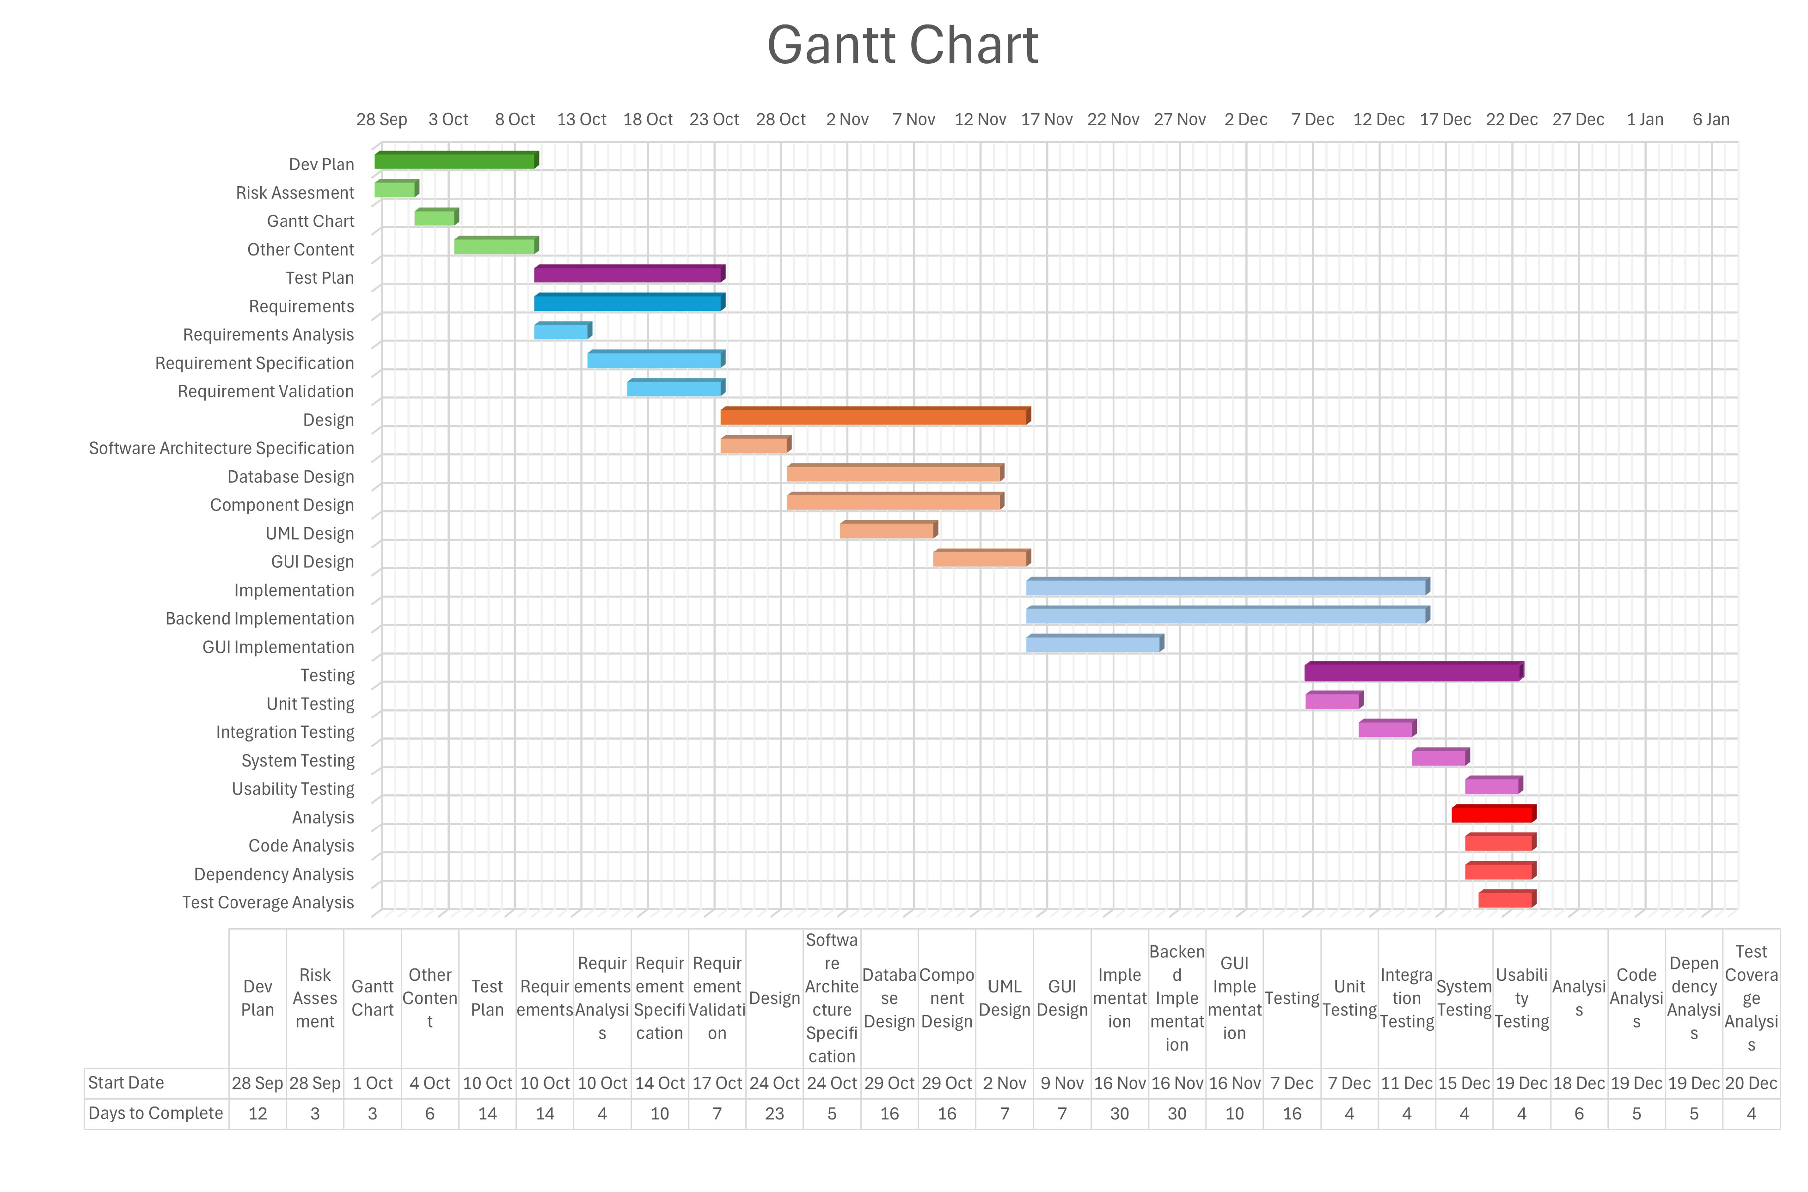
completion of the previous one. The following Gantt chart depicts the planned start date and duration for the phases.

Technical documentation

The following documentation is produced during the software development phases:
- Software specification: SRS, STP
- Software detailed conception: SDD
- Software tests phases : STR
- Software analysis: SAR

Deliverables

The following items will be delivered at the end of the process:
- Technical documentation as outlined in Section 2.1.2
- Software and its configuration files

Software development tools

Workstation

1-) Windows 11 Home 64-bit, CPU: Intel® Core™ i5-10300H (4C/8T up to 4.5 GHz), 8 GB Memory, GPU: NVIDIA GeForce RTX 1660 Laptop
2-) Windows 11 Pro 64 bit, CPU: Intel® Core™ i7-10750H (6C/12T up to 5 GHz) , 16 GB Memory, GPU: NVIDIA GeForce RTX 3060 Laptop
3-) Windows 11 Home 64-bit, CPU: Intel® Core™ i7-13650HX (24C/32T up to 5.6 GHz), 16 GB Memory, GPU: NVIDIA GeForce RTX 4050 Laptop

Requirements management and documentation

Microsoft Word, Google Documents

Software Design
Tools that will be used are:
- LucidChart

Coding and automated tests
- Visual Studio Code
- maven-compiler-plugin
- javafx-maven-plugin
- Junit
- Java
- JDBC
- IntelliJ IDEA
- MySQL

Configuration management
GitHub will be used for software configuration management and tracking issues regarding the software development. A public repository will be created for this purpose.

Software development rules and standards
UML will be used for software design documentation.

We follow standard Java coding conventions and software engineering best practices to ensure readability, scalability, maintainability, reusability, easy of review throughout this project.
http://www.oracle.com/technetwork/java/codeconvtoc-136057.html

Responsibilities

Activities and responsibilities

Activity | Responsibility | Comment
Project management | Özgür Yılmaz | -
Configuration tools management | Murat Tuna Özen | -
Setting up the Development tools | Murad Seyfullayev | IDE setup, library installation, version control (GIT) configuration, and environment standardization.
Database design | Alp Eren Erdur | ER(entity relations + constraints), DDL, DML
System Logo Design | Alp Eren Erdur | -

Risk Assessment

Risk Analysis

Risk | Probability | Effects
 | High | Serious
  The time required to develop and test the hospital management system is underestimated. (1)
 | High | Tolerable
  Integration between JavaFX UI, MySQL database, and the JDBC connection may fail or be unstable. (2)
The rate of bug fixing and testing may be underestimated. (3) | Moderate | Tolerable
 | Low | Tolerable
  Performance decreases with a large dataset (e.g., thousands of patient records). (4)
Documentation or code comments not kept up-to-date with code changes. (5) | High | Insignificant
Lack of sufficient test coverage (unit/integration tests). (6) | Moderate | Tolerable

Risk Planning

Risk | Strategy
  Development and testing time underestimated. (1)
  Reassess project schedule and redistribute workload among team members; prioritize core modules first and postpone non-essential features if necessary.
  Integration between JavaFX, MySQL, and JDBC unstable. (2)
  Perform early integration testing; validate database connection setup and JDBC driver compatibility; implement backup connection logic.
  Bug fixing and testing rate underestimated. (3)
  Allocate additional testing cycles; automate repetitive tests with JUnit; perform daily debugging sessions and peer reviews.
  Performance issues with large datasets. (4)
  Optimize SQL queries and database schema; apply indexing on frequently queried columns; test performance incrementally during development.
  Documentation not updated with code changes. (5)
  Enforce documentation updates during each commit; assign documentation responsibility to each module owner; conduct periodic code reviews for clarity.
 | Plan and execute unit tests for each module using JUnit; integrate test cases into Maven build; review test coverage before final deployment.
  Insufficient unit or integration test coverage. (6)

http://www.github.com
http://www.uml.org/

